Identified Need (or Challenging Situation) | Stressors or Escalating Factors | Goal | Supportive Interventions

Appendix:
Fig. 1. Window of Tolerance Diagram
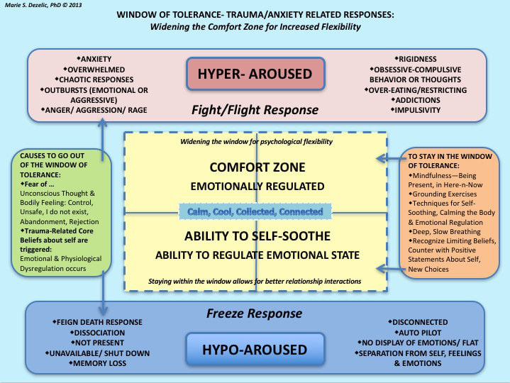
https://www.attachment-and-trauma-treatment-centre-for-healing.com/blogs/understanding-and-working-with-the-window-of-tolerance7

Fig 2. Principles of Trauma-Informed Approaches to Care
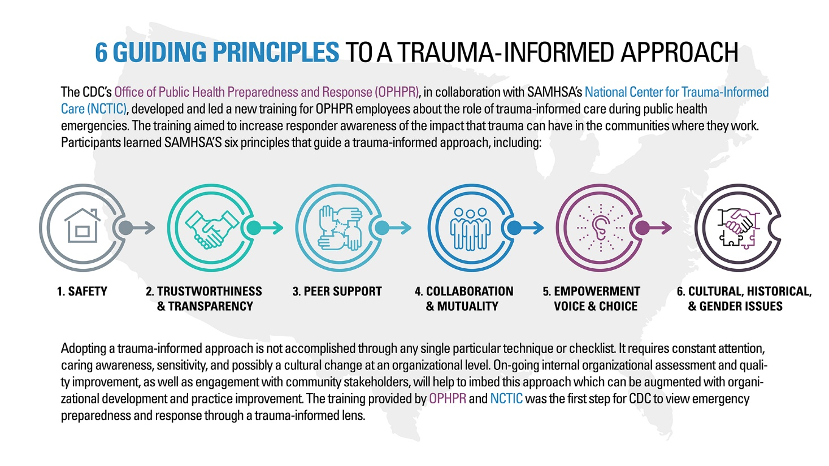
https://www.cdc.gov/cpr/infographics/6_principles_trauma_info.htm

