Safety Plan Template

Triggers & Stressors | Changeable:  Outside of Personal Control:
Warning Signs | Early:  Late:
Window of Tolerance | When a person is within their window of tolerance, it is generally the case that the brain is functioning well and can effectively process stimuli. That person is likely to be able to reflect, think rationally, and make decisions calmly without feeling either overwhelmed or withdrawn.  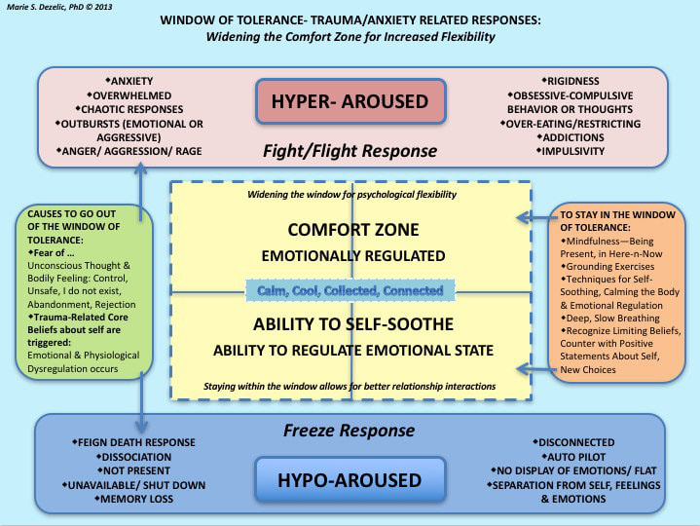  During times of extreme stress, people often experience periods of either hyper- or hypo-arousal.  “Hyper-arousal, otherwise known as the fight/flight response, is often characterized by hypervigilance, feelings of anxiety and/or panic, and racing thoughts.  Hypo-arousal, or a freeze response, may cause feelings of emotional numbness, emptiness, or paralysis.  In either of these states, an individual may become unable to process stimuli effectively. The prefrontal cortex region of the brain shuts down, in a manner of speaking, affecting the ability to think rationally and often leading to the development of feelings of dysregulation, which may take the form of chaotic responses or overly rigid ones.”
Coping Strategies & Distractions  *The higher the degree of distress, the better it is to seek out coping strategies & techniques that take minimal effort | Minimal Effort:  Moderate Effort:  Most Effort:
Reasons for Living  *There is no reason too small or insignificant | Short term:  Long term:
Supports | Professional:  Personal:
How to be Supportive in a Crisis Situation (for Loved Ones and Professionals

